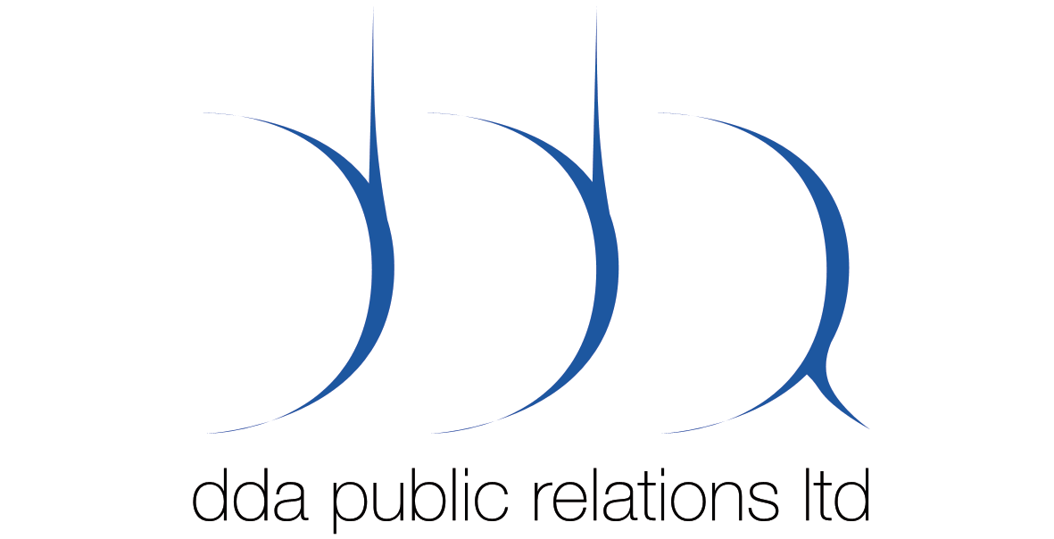

NEW LINE CINEMA ANNOUNCES OPEN UK
CASTING CALLS FOR LEAD ROLE IN

“THE GOLDEN COMPASS”

Search For Actress To Play “Lyra Belacqua” Comes To Four UK Cities – Cambridge, Kendal, Oxford and Exeter - starting April 4th.

LONDON, MONDAY MARCH 13TH, 2006: New Line Cinema, the studio behind the Oscar®-winning LORD OF THE RINGS trilogy, has launched a nationwide casting search in the UK to find a young actress to play the lead role of Lyra Belacqua in the highly anticipated feature film adaptation of Philip Pullman’s bestselling novel The Golden Compass, it was announced today by New Line Cinema and producer Deborah Forte. British director Anand Tucker (SHOPGIRL, HILARY AND JACKIE) is set to direct.

Lyra Belacqua, is one of the most beloved and spirited characters in children’s literature, and like her creator, a born storyteller. THE GOLDEN COMPASS casting directors Fiona Weir and Lucy Bevan are looking for a talented young actress who embodies Lyra’s loyalty, bravery and mischievous nature.

The initial open casting calls will take place in Cambridge, Kendal (in the Lake District), Oxford and Exeter during the first two weeks of April and are open to girls between the ages of nine and thirteen who are accompanied by a parent or guardian and resident in the UK. Applicants will be asked to complete a form and may be seen briefly by one of the casting directors. Children should come as themselves (no costumes or makeup allowed), dress warmly, and be prepared to wait. No previous acting experience is required. The Casting Calls, with queues open from 10am to 2pm and a 5pm close of the Call, will take place as follows:

DATE CITY VENUE
April 4 Cambridge The Corn Exchange April 6 Kendal The Cattle Green Hotel
April 11 Oxford The Examination School, The High
Street
April 13 Exeter The Great Hall, University Of Exeter

Based on the bestselling, award-winning and critically acclaimed Pullman novels, the His Dark Materials trilogy is comprised of The Golden Compass, the Subtle Knife, and The Amber Spyglass. It revolves around a young girl (Lyra) who travels to the far north to save her best friend. Along the way, she encounters shape-shifting creatures, witches, and a variety of otherworldly characters in parallel universes. THE GOLDEN COMPASS is directed by Anand Tucker and produced by Deborah Forte of Scholastic Media.

For further information, please contact:
Dennis Davidson/ Lawrence Atkinson
DDA PR:
E: dennis.davidson@ddapr.com / lawrence.atkinson@ddapr.com
T: +44 (0) 207 932 9800
W: www.ddapr.com

Notes to Editors:

About New Line Cinema Corporation:
Founded almost 40 years ago, New Line Cinema is the most successful independent film company in the world. Its mission is to produce innovative, popular and profitable entertainment in the best creative environment. In addition to the production, marketing, and distribution of theatrical motion pictures, the fully integrated studio has divisions devoted to home entertainment, television, music, theater, merchandising and an international unit. In 2005, New Line partnered with HBO to form Picturehouse, a new theatrical distribution company to release independent films. A pioneer in franchise filmmaking, New Line’s Oscar-winning THE LORD OF THE RINGS TRILOGY is one of the most successful film franchises in history. New Line is a division of Time Warner, inc. (TWX).

About Scholastic Media:
Scholastic Media is a leading producer of quality, family-oriented feature films, television programming, videos, and web sites and is a major developer and marketer of children's brands worldwide. A division of Scholastic, the global children's publishing, education and media company, Scholastic Media produces the award-winning, top-rated animated series Clifford The Big Red Dog® (PBS KIDS®); the Emmy-award winning spin-off to this hit series, Clifford's Puppy Days(tm) (PBS KIDS); the Emmy-award winning series I SPY (HBO Family) and The Magic School Bus®(TLC), starring Lily Tomlin; the award-winning Dear America® series; and the popular kids' adventure series Animorphs® and Goosebumps®. In October 2004, Scholastic Media's new series, Maya & Miguel(tm) debuted on PBS KIDS GO! Scholastic Media's critically acclaimed feature films include Clifford's Really Big Movie, The Baby-sitters Club, The Indian in the Cupboard, and The Mighty.

ENDS/.

